Proposed Merger of Canadian Pacific Railway Limited and Kansas City Southern
On October 29, 2021, Canadian Pacific Railway Limited, et al. (CP) and Kansas City Southern et al. (KCS) filed an application with the Surface Transportation Board (Board) seeking authorization for CP to acquire KCS. To thoroughly assess potential environmental impacts that may result from the Proposed Acquisition, the Board’s Office of Environmental Analysis (OEA) has prepared a Draft EIS pursuant to the National Environmental Policy Act (NEPA) and related laws, including Section 106 of the National Historic Preservation Act.
The Board’s Office of Environmental Analysis (OEA) prepared this Draft Environmental Impact Statement (Draft EIS) to analyze the environmental impacts of the Proposed Acquisition. OEA also considered the No-Action Alternative, which would occur if the Board were to deny authority for CP to acquire KCS. Under the No-Action Alternative, OEA anticipates that rail traffic would only increase on the CP and KCS networks as a result of general economic growth and that the Applicants would not add the planned capital improvements.
The Draft EIS describes the potential direct, indirect, and cumulative environmental impacts of the Proposed Acquisition on freight and passenger safety, grade crossing safety and delay, truck to rail diversion, intermodal facility traffic, noise, air quality, climate change, energy, cultural resources, hazardous material release sites, biological resources, water resources, and environmental justice.
Comment Period: Comments are due on September 26, 2022.
Written comments on the Draft EIS may be submitted through the Board’s website at
www.stb.gov or sent by mail to:
Joshua Wayland
Surface Transportation Board
Environmental Filing, Docket No. FD 36500
c/o VHB
940 Main Campus Drive Suite 500
Raleigh, NC 27606

The public meeting schedule for in person and online meetings is as follows:
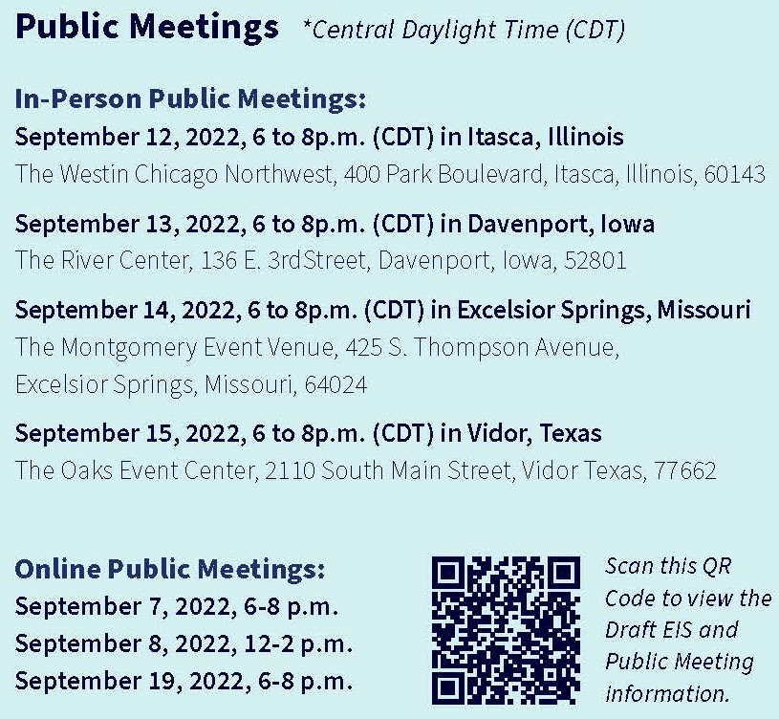

- INTRODUCTION

The proposed merger of the Canadian Pacific and Kansas City Southern railways poses a significant environmental impact in Iowa. The Draft EIS describes the potential direct, indirect, and cumulative environmental impacts of the Proposed Acquisition on freight and passenger safety, grade crossing safety and delay, truck to rail diversion, intermodal facility traffic, noise, air quality, climate change, energy, cultural resources, hazardous material release sites, biological resources, water resources, and environmental justice.

As noted in the Draft EIS, the largest expected change would occur on the CP mainline between Sabula, Iowa, and Kansas City, Missouri, where the Applicants project that rail traffic would increase by approximately 14.4 trains per day, on average. The Iowa section impacted by this increase in traffic is highlighted in the map below. Increased rail traffic has the potential to result in environmental impacts related to noise and vibration, air quality, freight and passenger rail safety, grade crossing safety and delay, passenger rail transportation, and hazardous material transportation.

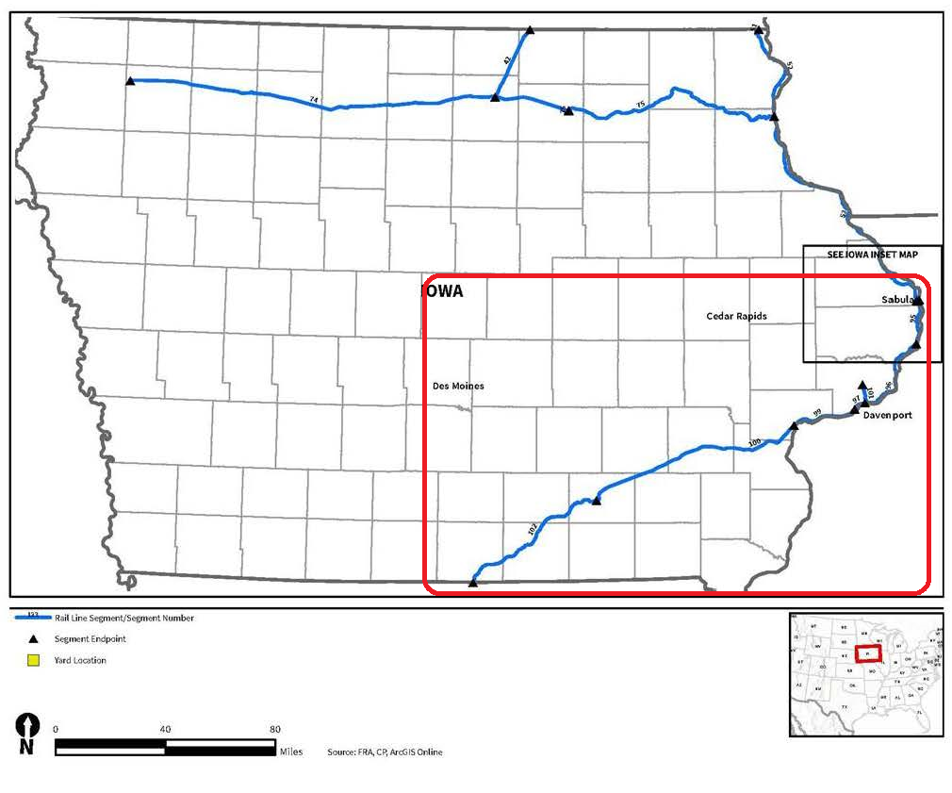
- Iowa Northern Rail Segments

Although the impacts are larger in the Sabula to the Missouri border rail segment, the northern rail segments in Iowa also would experience significant environmental impacts

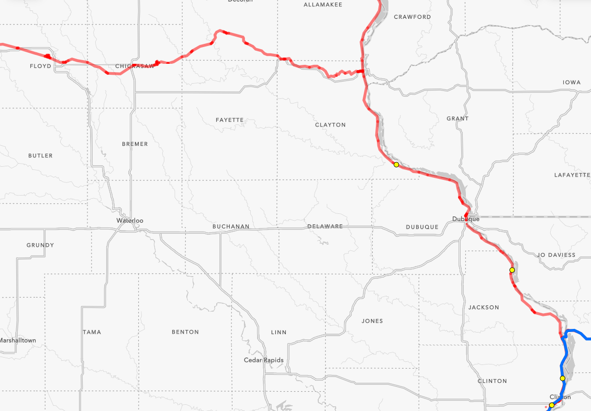
Given the railways close proximity to the Mississippi river, the following identifies the impacts of the proposed merger to the impacted communities and the potential risks.

- Lansing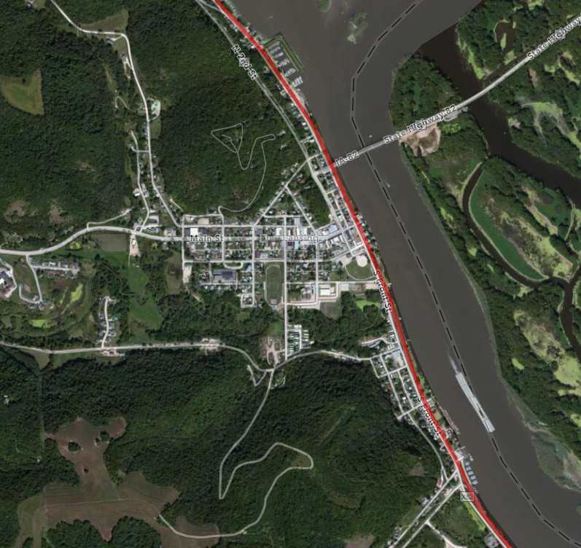

 | Current | After Merger | % Increase
TPD (average)* | 4.66 | 11.28 | 142
Hazmat Carloads | 71,079 | 130,654 | 84
Grade Crossing Time | Not identified | Not identified
* Average number of trains per day
b) Harpers Ferry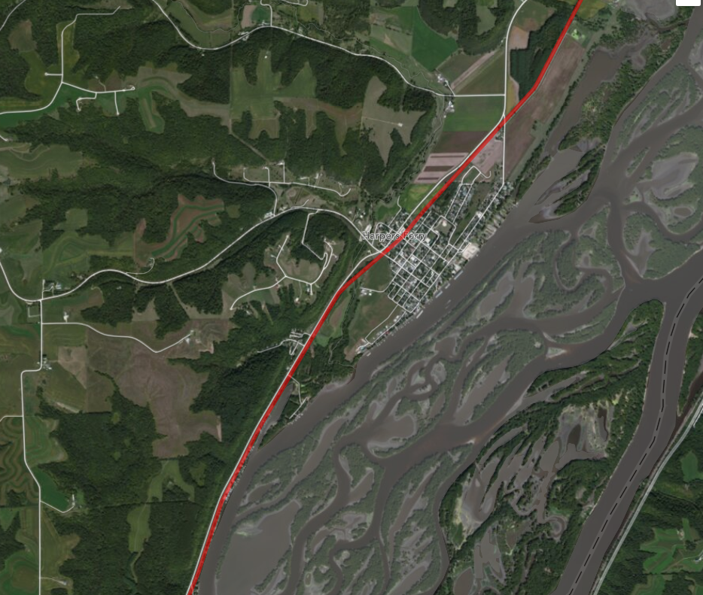

 | Current | After Merger | % Increase
TPD (average)* | 4.66 | 11.28 | 142
Hazmat Carloads | 71,079 | 130,654 | 84
Grade Crossing Time | Not identified | Not identified
* Average number of trains per day
c) Marquette and McGregor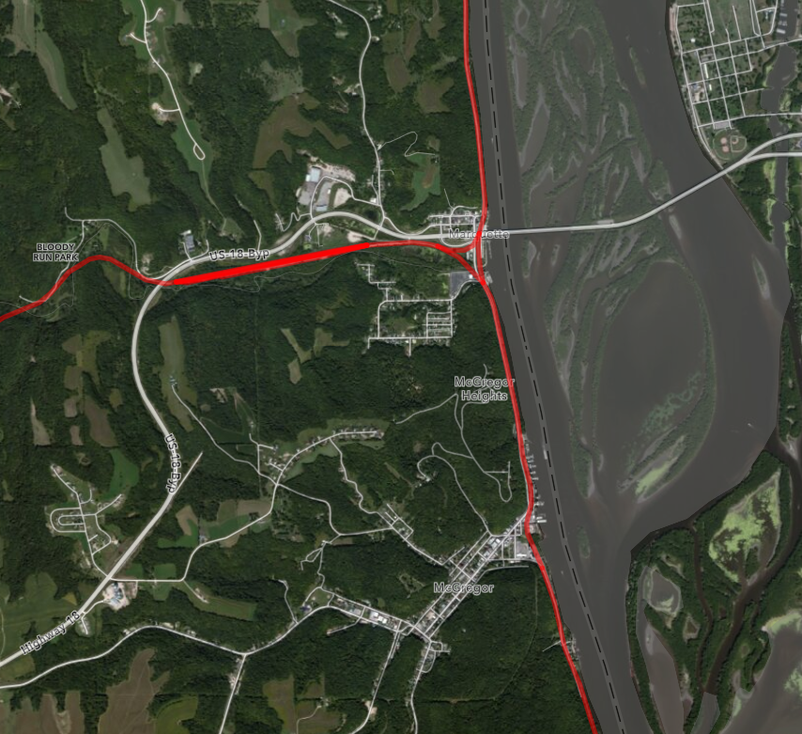

 | Current | After Merger | % Increase
TPD (average)* | 4.66 | 11.28 | 142
Hazmat Carloads | 71,079 | 130,654 | 84
Grade Crossing Time | Not identified | Not identified
* Average number of trains per day
d) Guttenberg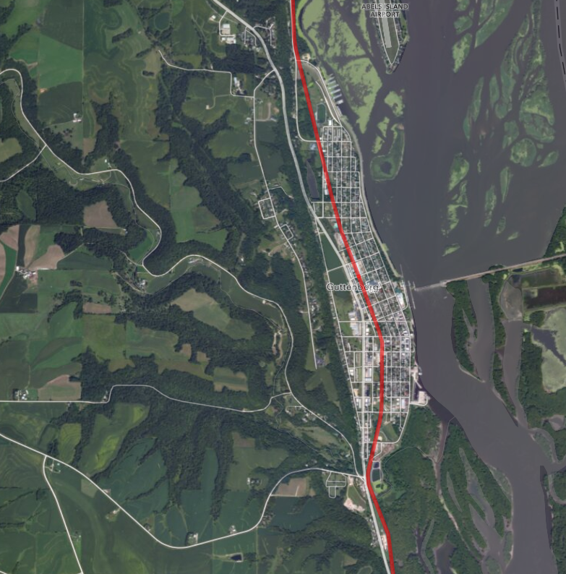

 | Current | After Merger | % Increase
TPD (average)* | 10.7 | 17.97 | 68
Hazmat Carloads | 129,465 | 205,312 | 59
Grade Crossing Time | Not identified | Not identified
* Average number of trains per day
e) Dubuque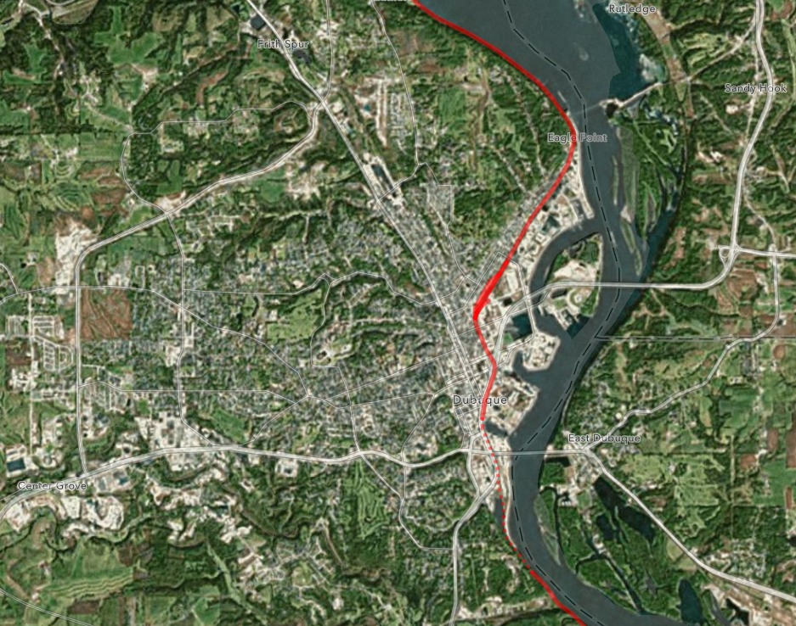

 | Current | After Merger | % Increase
TPD (average)* | 4.66 | 11.28 | 142
Hazmat Carloads | 71,079 | 130,654 | 84
Grade Crossing Time | Not identified | Not identified
* Average number of trains per day

- Iowa Southern Rail Segments

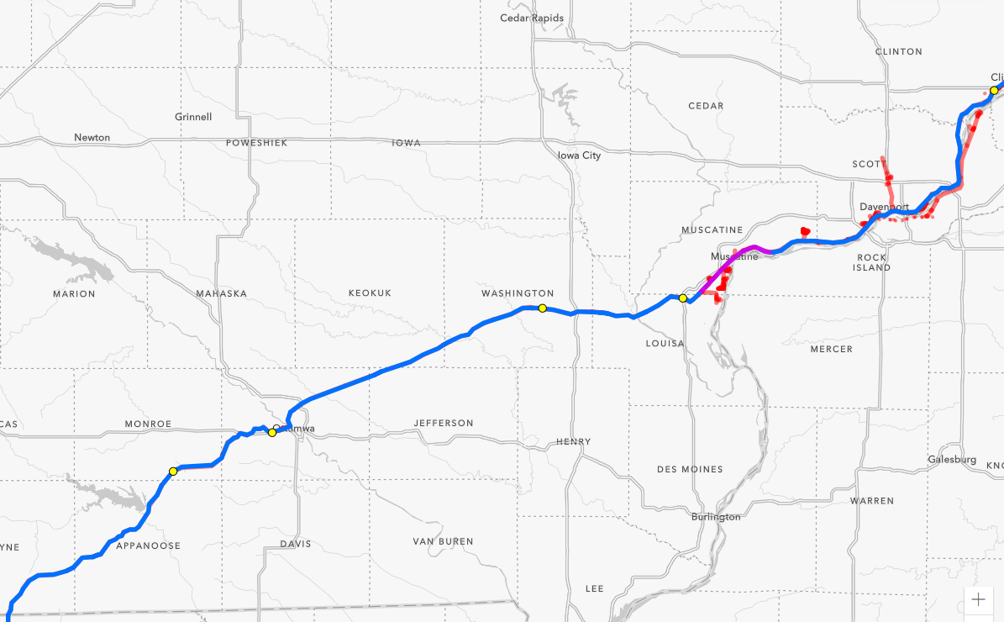

Each of the rail sections in Southern Iowa in addition to identifying the increase in the number of trains per day, the increase in the number of rail cars containing hazardous materials, and the increase in the delays at rail crossing, identifies the environmental justice impact of the proposed merger.
Areas highlighted in yellow are census tract areas with low-income and minority populations.
Areas highlighted in green are census tract areas with low-income populations.
Areas highlighted in blue are census tract areas with minority populations.
- Clinton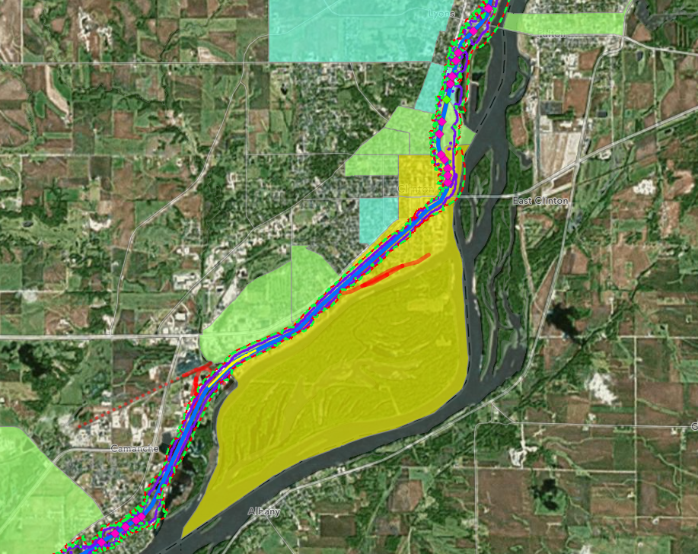

 | Current | After Merger | % Increase
TPD (average)* | 10 | 25.14 | 151
Hazmat Carloads | 26,829 | 77,771 | 190
Grade Crossing Time | 1 Hour 4 Min | 2 Hours 18 Min | 116
* Average number of trains per day
b) Davenport and Rock Island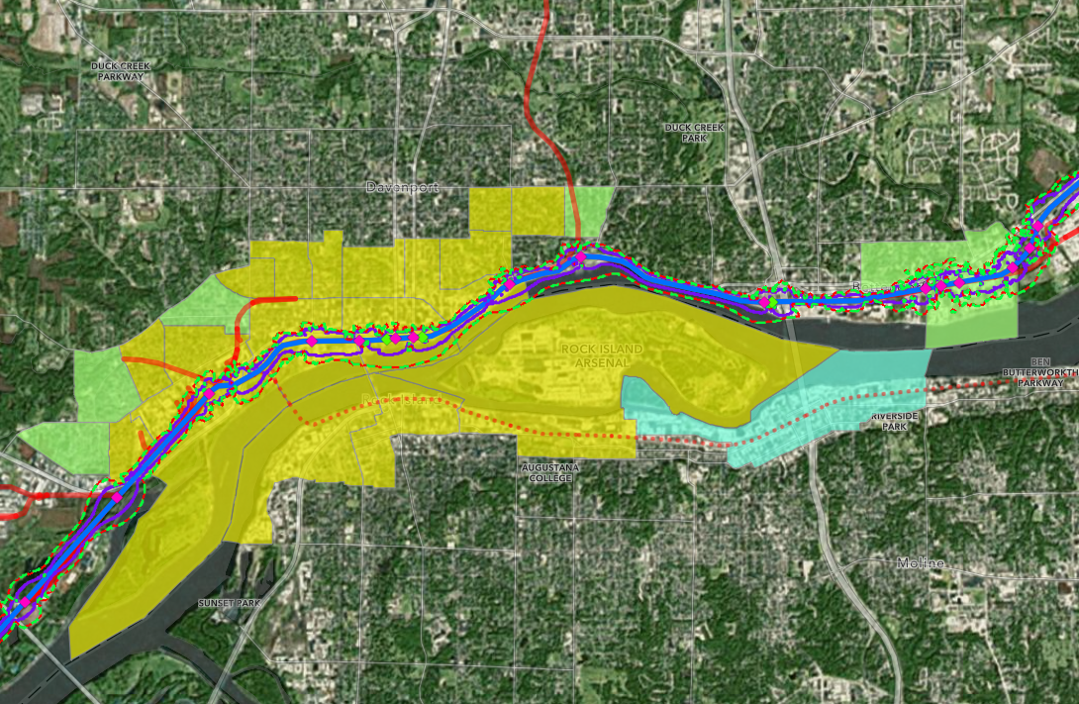

 | Current | After Merger | % Increase
TPD (average)* | 7.97 | 22.67 | 184
Hazmat Carloads | 23,379 | 74,016 | 217
Grade Crossing Time | 42 Min | 1 Hour 42 Min | 143
* Average number of trains per day
c) Muscatine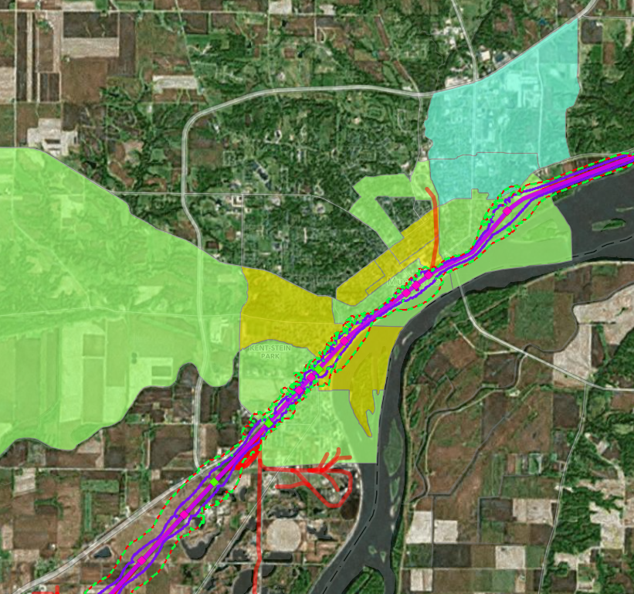
 | Current | After Merger | % Increase
TPD (average)* | 6.09 | 20.78 | 241
Hazmat Carloads | 19,884 | 69,117 | 248
Grade Crossing Time** | 2 Hours 15 Min | 5 Hours 45 Min | 156
* Average number of trains per day
**Mississippi Drive
d) Columbus Junction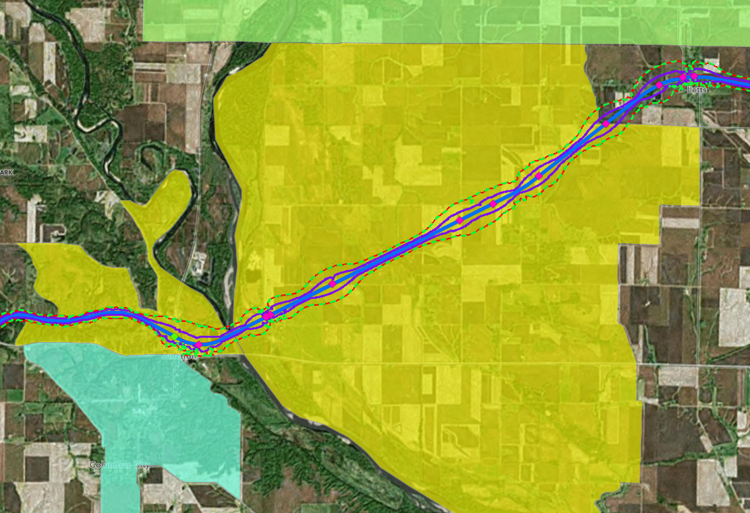

 | Current | After Merger | % Increase
TPD (average)* | 4.3 | 19.21 | 347
Hazmat Carloads | 21,384 | 70,886 | 231
Grade Crossing Time | Not identified | Not identified
* Average number of trains per day

e) Washington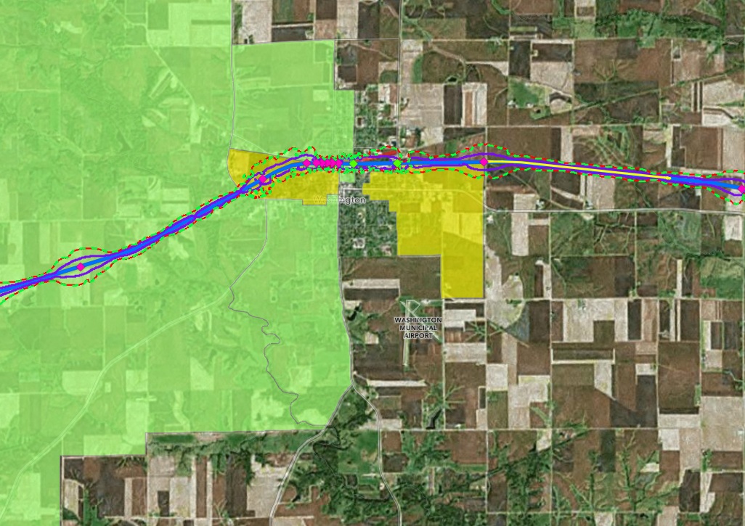

 | Current | After Merger | % Increase
TPD (average)* | 4.3 | 19.21 | 347
Hazmat Carloads | 21,384 | 70,886 | 231
Grade Crossing Time | 14 Min | 50 Min | 257
* Average number of trains per day
f) Ottumwa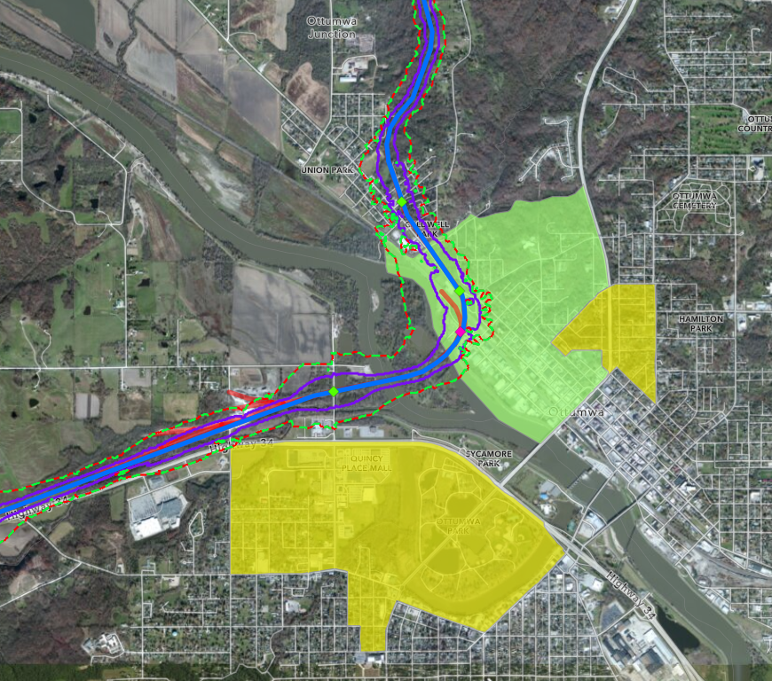

 | Current | After Merger | % Increase
TPD (average)* | 3.17 | 17.81 | 462
Hazmat Carloads/yr | 32,208 | 84,425 | 162
Grade Crossing Time | 29 Min | 1 Hour 28 Min | 205
* Average number of trains per day
g) Moravia and Lake Rathbun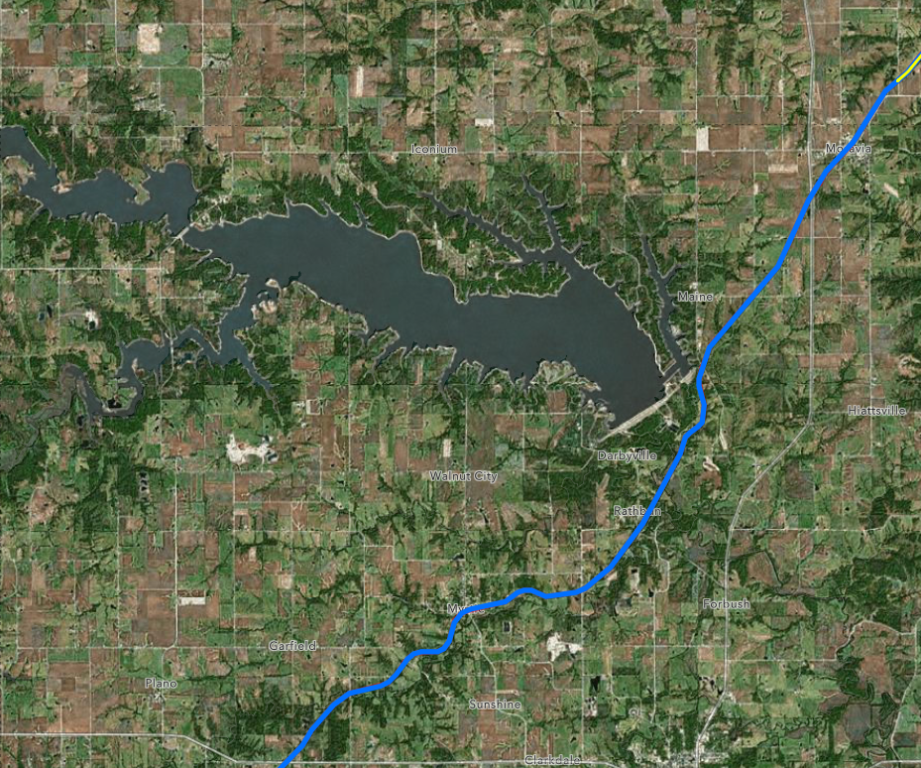

 | Current | After Merger | % Increase
TPD (average)* | 3.17 | 17.81 | 462
Hazmat Carloads/yr | 32,208 | 84,425 | 162
Grade Crossing Time | 13 Min | 46 Min | 254
* Average number of trains per day

- Derailments
Canadian Pacific, et al has reported 26 main line derailments.
Accident Details | FRA (dot.gov)
